EOC Outdoor Master User Manual

Catalogue

1 Introduction 2
1.1 Application 2
1.2 Commitment 2
1.3 Packing List 2
2 Installation preparation 3
2.1 Product Drawing 3
2.2 Description of LED 3
2.3 Description of Interface 3
2.4 Functional Feature 4
2.5 Installation environment 4
2.6 Steps of installation 4
2.7 Network diagram 5
2.8 Frequency Question Answer 5
2.9Attention 6
3 Equipment test 7
3.1 Web configuration 7
3.2 CLI configuration 7
Appendix one: Disclosure Table 9

Introduction
Thanks for using our EOC Master!
EOC Master is an Ethernet access equipment design for solving Two-way Reconstruction in CATV Network. Its uplink port connects to IP Port and downlink mix CATV signal to deliver TV program and IP data. We offer diversified and customized service to you.
It’s very easy to install EOC Master so you can finish the configuration according to this user’s manual. Before using our equipment, please read this book.

1.1 Application
The user manual will help you to know and use EOC Master correctly.

1.2 Commitment
Equipment mentioned in this manual refers to EOC Master without special description.

1.3 Packing List
One packing box includes:
- One EOC master
- One user manual
- One Quality Passed Certificate

Installation preparation

2.1 Product Drawing
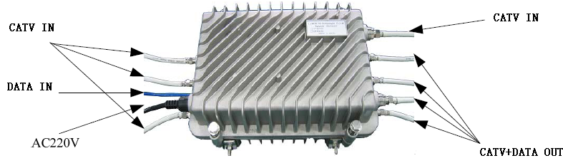
2-1 schematic diagram

2.2 Description of LED

Item | Label | Action | Description
Power Indicator | POWER | off | Without electricity
Power Indicator | POWER | on | OK
Ethernet | ETHERNET | on | Physical link not connected
Ethernet | ETHERNET | off | Physical link is OK
System Indicator | SYSTEM | off | System doesn’t start
System Indicator | SYSTEM | on | System starts
Indication of PLC linking and action | LINK | off | Coaxial cable is not connected or connect in a wrong way
Indication of PLC linking and action | LINK | on | Coaxial cable connect correctly

2.3 Model
Product name | Model | Description
int6400 Series | CD6101 | 1RF Input,1 Data Input,1COM Output Master, Outdoor type
int6400 Series | CD6101-F1 | 1RF Input,1 Data Input,1COM Output ,1 Fiber Optic Media Converter ,Master, Outdoor type
int6400 Series | CD6112 | 2RF Input,2 Data Input,2COM Output Master, Outdoor type
int6400 Series | CD6114 | 4RF Input,2 Data Input,4COM Output Master, Outdoor type
int6400 Series | CD6611 | 1RF Input,1 Data Input,1COM Output ,1ONU,Master, Outdoor type
int6400 Series | CD6622 | 2RF Input,2 Data Input,2COM Output,1ONU, Master, Outdoor type
int6400 Series | CD6624 | 4RF Input,2 Data Input,4COM Output,1ONU, Master, Outdoor type
int7410  Series | CD7101 | 1RF Input,1 Data Input,1COM Output Master, Outdoor type
int7410  Series | CD7101-F1 | 1RF Input,1 Data Input,1COM Output ,1 Fiber Optic Media Converter ,Master, Outdoor type
int7410  Series | CD7112 | 2RF Input,2 Data Input,2COM Output Master, Outdoor type
int7410  Series | CD7114 | 4RF Input,2 Data Input,4COM Output Master, Outdoor type
int7410  Series | CD7611 | 1RF Input,1 Data Input,1COM Output ,1ONU,Master, Outdoor type
int7410  Series | CD7622 | 2RF Input,2 Data Input,2COM Output,1ONU, Master, Outdoor type
int7410  Series | CD7624 | 4RF Input,2 Data Input,4COM Output,1ONU, Master, Outdoor type

Note: Product you get depends on goods

2.4 Functional Feature
- Support tree-type and star-type CATV network.
- Built-in isolation filter with high functionality.
- Support user to log in through Web interface to centralize management on the EOC slaves under the master, including VLAN configuration, QoS configuration, port management, log in permission management, status information inquiry and update software.
- Support user to log in EOC Master through Console Port,Telnet and configured it.
- Support EMS network management.

2.5 Installation environment
Requirements:
- Far away from heat emitted devices
Suitable environment:
- Temperature: -20℃～50℃
- Humidity: 10﹪～90﹪(Non condensing)

2.6 Steps of installation
Please install EOC Master as follows:
- Set up WAN link
Link the cable to LAN. You also can connect the equipment with PC in order to configure EOC Master and manage network.
- Connect CATV network
Please connect CATV signal to master’s F-connector (CATV INPUT) via coax cable and the other F-connector marked as CABLE combine the CATV and data signal output to the distribution networking ,finally accessing to the EOC Slave in the subscriber end.

⑶ power supply requirement
If equipment has electricity, it will start to work automatically.
You can link equipment as follows:
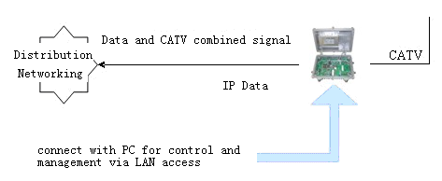
2-2 Connection Figure
(4)Notice

- Each equipment connects to RF port with coaxial cable. Please do not touch the cable’s manual connector in case of any interference in communication quality.
- Circumscribed repeater or bridge unit should be put besides Amplifier.
- If the high level output signal from the EOC master is not filtered well ,it may has impact on the catv channel .In this case ,please add a high passing filter on the catv link to isolate the eoc signal totally .

2.7 Network diagram
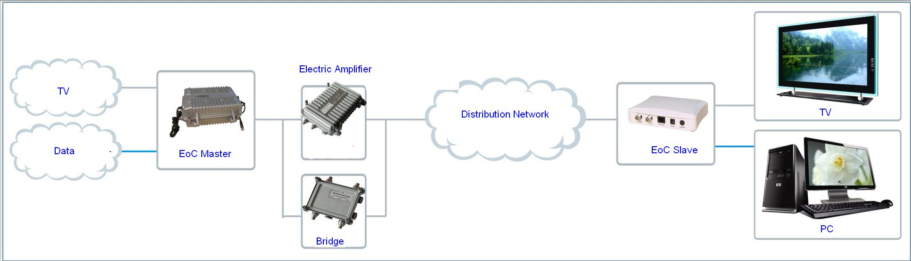
2-3 Network diagram

2.8 Frequent Question and Answer
- Power light does not shine
- Check if the power adapter works well.
- Check if the power connector is corrected
- System light does not shine
- Use millimeters to check whether 220V/60V input is correct. If not, please change another power adapter.
- Check whether IP is connecting. If yes, maybe there is something wrong with Ethernet LED.
- Ethernet light does not shine
- Check the validity of the cable connections; check whether the master panel's indicator light flashing; and check whether cable is working.
- Check if cable connects to equipment.
- Cable light does not shine.
1) Maybe there is no user access.
2) If there are user access, please press reboot button.
3) Check whether Master is correct. If yes, it means the cable light has something wrong. But it won’t influence machine’s working.
- When there is no data signal input to distribution networking node, EOC Slave CABLE LED is off or flashing.
- Disconnect the link and check if the link attenuation is within 60dB,or check if digital /analog TV is working normally. If not, please maintain the coax cable link.
- CABLE LED is flashing, indicating there is too much interference .Please check the coax cable networking construction is standard or not .If there is too messy; please maintain the coax cable link.
- The electric amplifier doesn’t connect with the bridge .If so ,please connect the bridge to the amplifier .

2.9Attention
There is something to be mentioned when you use it:
- All Installation and adjustment must follow user’s manual.
- Pay attention to all alarm mark.
- Avoid small metal component entering into equipment.
- Please switch off the power when it’s not used for a long time.
- If there is something wrong with the equipment, please contact with professional engineers for instruction.
- Avoid putting equipment in aisle or other places where is crowded with residents.
- Check if ground connection is done well.

Equipment test

3.1 Web configuration
Input IP (LAN IP :192.168.2.2)of EOC equipment in IE explorer and write down username and password (admin/admin). You will see following interface:
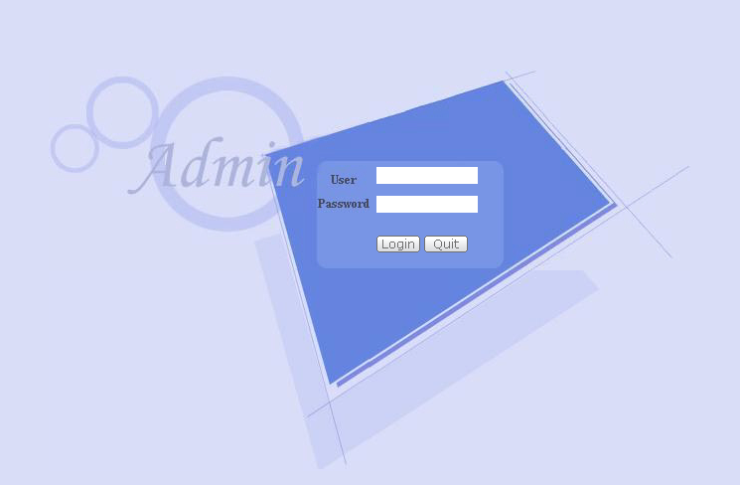

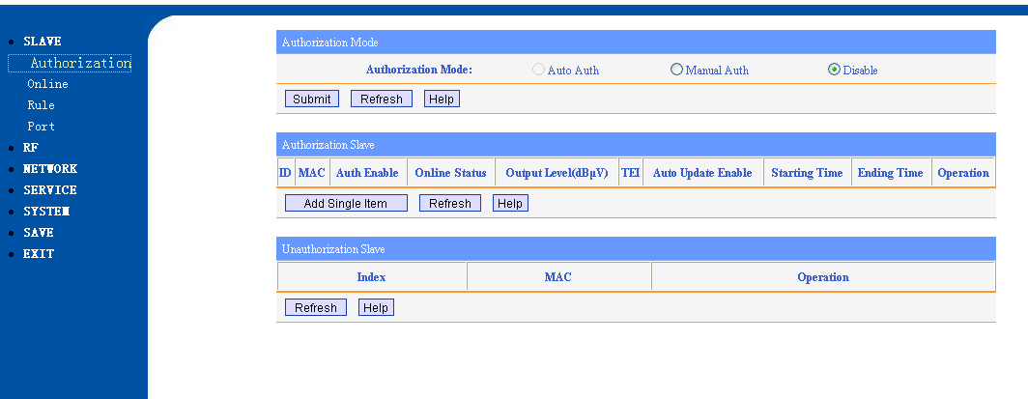
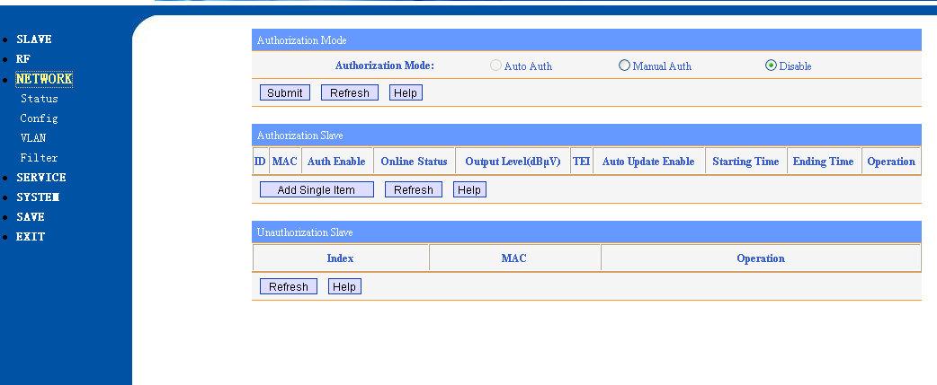
3-1 Web management

You can configure IP, VLAN, and QOS in Web interface. If there is any problem, please contact with our technology staff.

3.2 CLI configuration
Click “start”－Enter telnet IP
Enter user’s name and password (admin/admin), and then you can start to configure equipment.
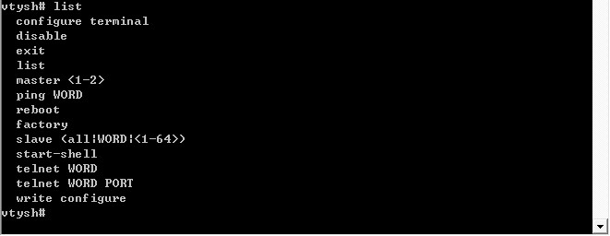
3-2 CLI management
You can set IP, VLAN and QOS by CLI. If you have any problem, please contract our technology staff.

Appendix one: Disclosure Table
Parts | Hazardous Substance
Parts | Pb | Hg | Cd | Cr6+ | PBB | PBDE
Placode |  | ○ | ○ | ○ | ○ | ○
Plastic element | ○ | ○ | ○ | ○ | ○ | ○
Metal element | ○ | ○ | ○ | ○ | ○ | ○
Packaging material | ○ | ○ | ○ | ○ | ○ | ○
Accessory | ○ | ○ | ○ | ○ | ○ | ○
○: Indicates that this toxic or hazardous substance contained in all the homogeneous material, is below the limit requirement of SJ/T11363-2006.
: Indicates that his toxic or hazardous substance contained in all the homogeneous material fort is beyond the limit requirement of SJ/T11363-2006.

